Team Vitruvian
Halil Can Memoglu, Chloe Dietz, Abraham Milhem, Ajmain Hossain
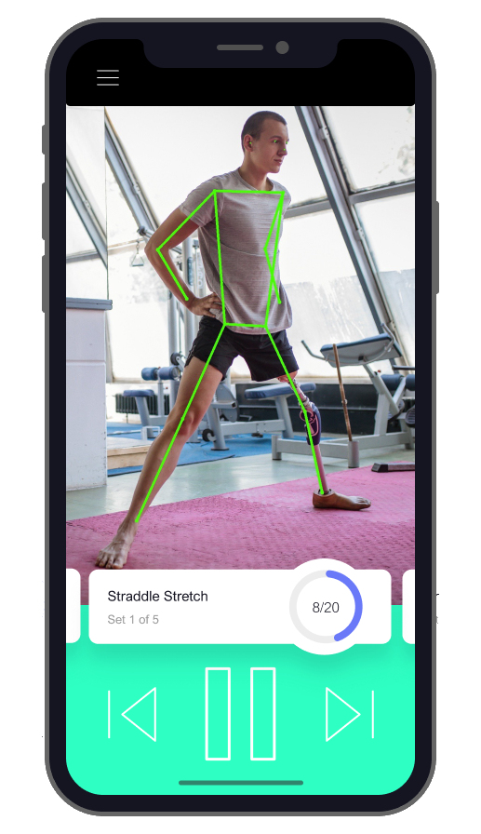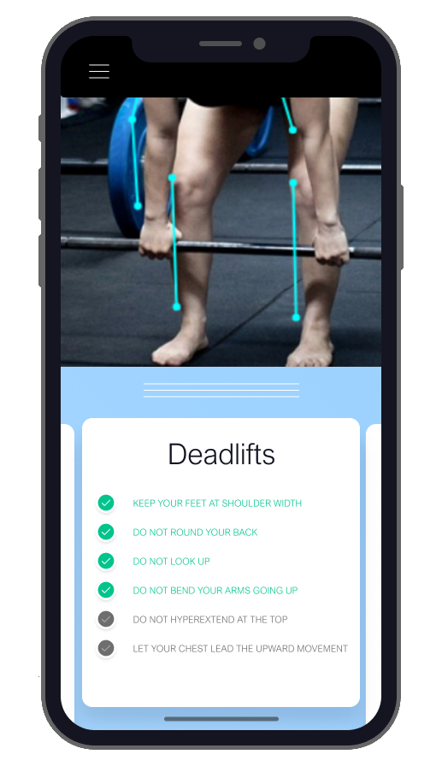
Executive Summary
Vitruvian is a machine learning platform that allows users to detect, track, count, and correct physical exercise movements detected through a camera. Poorly performed or selected exercise can lead to otherwise avoidable consequences from suboptimal performance to significant injury. On the other hand, well-performed exercise will increase performance and pursuant wellness significantly. Thus, increasing the safety and effectiveness of physical exercise at a significantly lower price point than before will allow us to make physical health easier, more enjoyable, and faster to attain for everyone. Most importantly, the more the users utilize our service, the more accurate and valuable it will get. We will then derive most of our revenue from selling the analysis capabilities of that uniquely improved deep learning model as a service.
Engineering Progress Since December
On the fifteenth of December, our greatest technical achievement was having integrated a Python-bound PoseNet Machine Learning model with a Tello drone platform. However after listening to the feedback of our M&T and engineering advisers, we chose a more accessible and valuable business idea for the underlying technology that we had. To achieve this, we have made significant changes to the technical side of our project:
- We needed to be able to deploy our product as widely as possible while still adhering to time limitations. We decided to turn the user-interaction layer of the product from a robot-borne app or a native-mobile app into a web-based application. Since nearly all internet-capable devices can run Javascript, nearly all internet-capable devices would now be able to run Vitruvian. Thus we switched the Python-to-C++ bindings into Javascript-to-C++ bindings.
- Given that a mobile phone provided a fixed perspective with a 2d camera (as opposed to a mobile robot or a 3d camera), we had to figure out a way to overcome the disadvantages of being left immobile with no depth perception. To do this, we did the following:
  - We probabilistically integrated some assumptions about the human body into how the analysis algorithm builds the 2d-to-3d mapping of the video feed to a virtual 3d skeleton. For instance, the ratio of arm-sizes is a significant data point for corrective linear manipulation.
  - Focusing our goals from general-purpose activity detection to detecting and tracking a relatively small number of distinctive exercises, we used user prompts and the exercises themselves to limit the algorithm’s “plausible” set of detected joints. For example, the shape of a push-up provides significant limitations to what the algorithm would expect, which significantly helps to increase accuracy.
- As seen in the first slide with two screens, we made considerable progress with the design. The live link to our online designs, if you would like, is here.

As mentioned, both the locally-run and cloud-based platforms share a common web-app architecture for universal deployment. Here is the link: https://halilcan.github.io/VitruvianJS.
Business Analysis
We are providing AI-based fitness expertise as a service. The first use-case we will develop is personal use through mobile phones. We will use the same technology to quickly develop team/enterprise applications for coaches, remote trainers, fitness centers. Furthermore, increased usage will improve the accuracy of the deep learning model, which will then make the service more valuable cyclically.
For individual users, effective physical training requires persistent determination, research ability, and discipline. These do not account for the sheer physical strain itself. Therefore, it should come as no surprise that while hundreds of millions will pledge to be physically healthier every New Year’s Eve, more than 60% of them will abandon their resolutions before Spring (link). Thus we see the opportunity: We all desire to be physically healthier, but few of us can demonstrate the grit required. This is where the value lies.
For general use, we will focus on the factors that make physical exercise easier and more enjoyable. These are quantifiability, low cognitive load, variety in activities, realistic plans, and observable results (link). The only major factor that we do not target is social approval. Our reasoning is that current use patterns of social media does not improve but damage mental health (link). Since such a response would reduce the likelihood of continued physical effort, it is counterintuitive. We will target the aforementioned factors to increase short-term observable returns to physical exercise. Since early performance in physical exercise is found to be a very good predictor for continued exercise, and physical health is correlated strongly with mental health, we believe this strategy has merit (link).
As you can guess by now, it is not our primary intention to turn our initial users into our primary revenue stream. Consider how Google provides reCaptcha as an anti-bot service to countless other companies while using the data thus collected to further increase the accuracy of their machine learning models. This is our framework: We will make physical exercise easier and more rewarding for the users of our mobile product. While there will be premium features, most functionality will be free. These users’ feedback and fitness programming will furter train our underlying deep learning model. Then, we will sell our uniquely-valuable, enterprise-grade fitness expertise AI’s analysis capabilities to teams and businesses that would particularly value it.
Data is king in machine learning, and this is how we will get it.

